**Types of ML (How model learn)**

1. Instance based
2. Model based

Generally, humans learn in two fashions.

1. Memorizing
2. Generalization

Similarly, Machine learn in these two types of fashions.

* **Instance based learning:** In machine learning, instance-based learning (sometimes called memory-based learning) is a family of learning algorithms that, instead of performing explicit generalization, compare new problem instances with instances seen in training, which have been stored in memory. Or you can say when you model starts (ratta) of your dataset is called instance-based learning.

In this type of learning we calculate the distance to nearest neighbors. This algo is called KNN. There is no concept of actual learning or training process in instance learning. It only holds the data. When new data comes in it start measuring the distance to its neighbors.

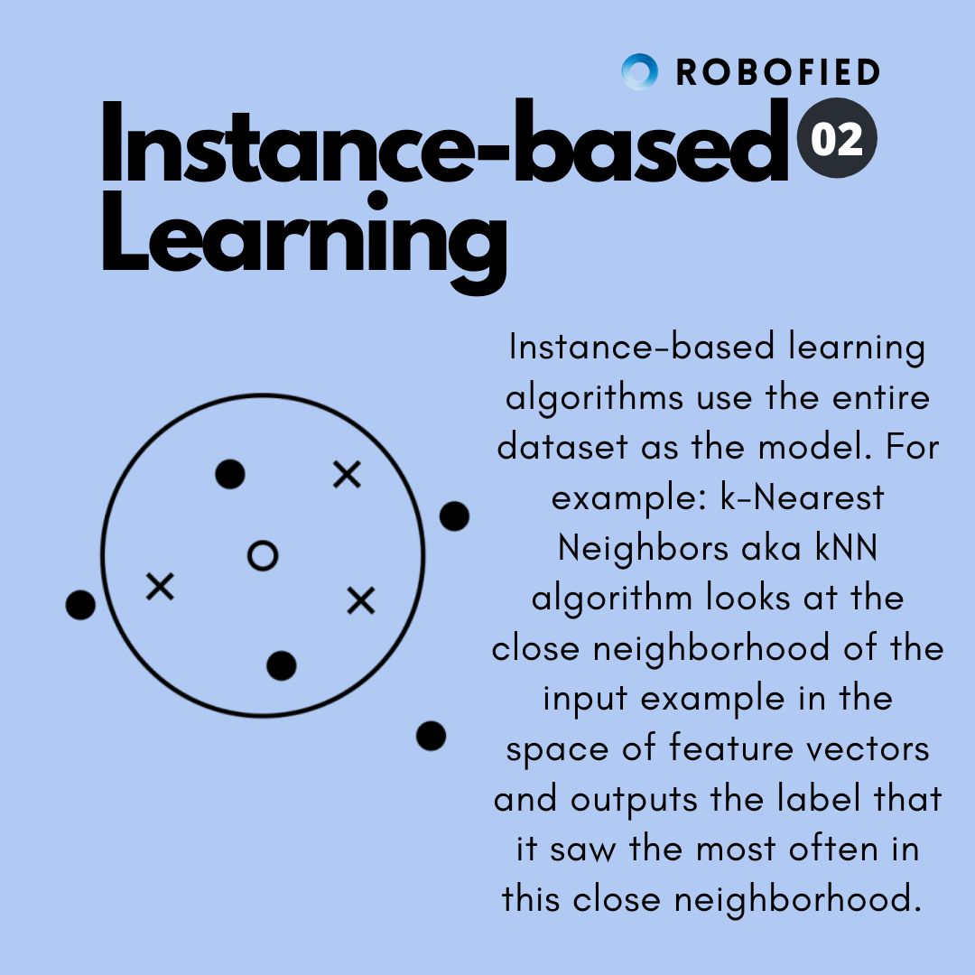

* **Model based learning:** In model based learning your model draws a line between data points on the basis of which it can decide the result of new incoming data. This boundary can be called decision boundary like in classification problem. In this learning we really don’t need data points how let suppose when we dig into the data and learn the boundary line or you can say concept of classifying the data on the basis of input then if our data point are no more longer available even then we are able to classify the new input on the basis of concept we learn.

**Example :** Linear regression, logistic regression, decision trees etc..

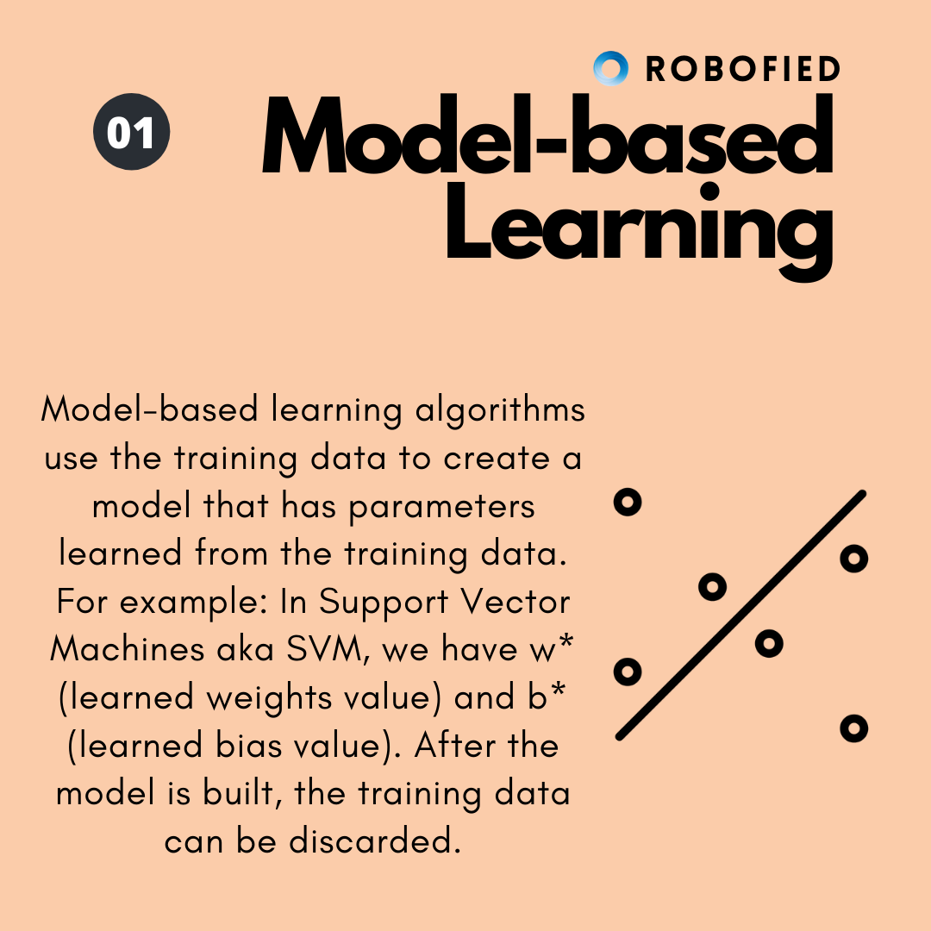

|  |  |
| --- | --- |
| **Model based** | **Instance based** |
| Prepare data for model training | Same as model |
| Train model from training data to estimate model parameters. | Do not train model. Pattern discovery postponed until query received. |
| Store the model in suitable form | There is no model to store |
| Generalize the rules in form of model even before scoring instance in seen. | No generalization before scoring. Only generalize for each scoring instance. |
| Predict for unseen scoring instance using model. | Predict for unseen scoring instance using training data directly |
| Can throw away input/training data after model training. | Data must kept since each uses part or full data. |
| Requires a known model form storing models generally requires less storage | May not have explicit model form. Storing training data generally requires more storage. |